|  |  |
| --- | --- |
| **STOCK PRICE PREDICTOR** | GROUP MEMBERS:  ABDULLAH TANWEER (23SP-005-SE) TAHA IMRAN (23SP-022-SE) MUHAMMAD ADEEL (23SP-014-SE) |

**AI Stock Predictor Model Report: Apple Inc. (AAPL)**

# Problem Statement:

Stock market prediction has long been a domain of interest for financial analysts and investors. With the rise of machine learning and AI, predictive models can now process large volumes of financial data to detect patterns, forecast trends, and support investment decisions.

This project aims to develop an AI-powered model to predict **Apple Inc. (AAPL)** stock prices using historical data. Apple is one of the most valuable and actively traded stocks, making it an ideal candidate for modeling and analysis.

**Objectives:**

* + Predict future stock prices of Apple Inc.
  + Compare multiple machine learning algorithms for prediction performance.
  + Evaluate which model provides the most reliable forecast for investment purposes.

# Dataset Details

**Source:**

<https://www.investing.com/equities/apple-computer-inc-historical-data>

**Ticker:** AAPL

## Data Fields:

* + Date
  + Open Price
  + High Price
  + Low Price
  + Close Price

**Date Range:** January 2021 – Dec 2024

**Frequency:** Daily

## Preprocessing Steps:

* + Split into training (90%) and testing (10%) datasets.

# Methodology Diagram

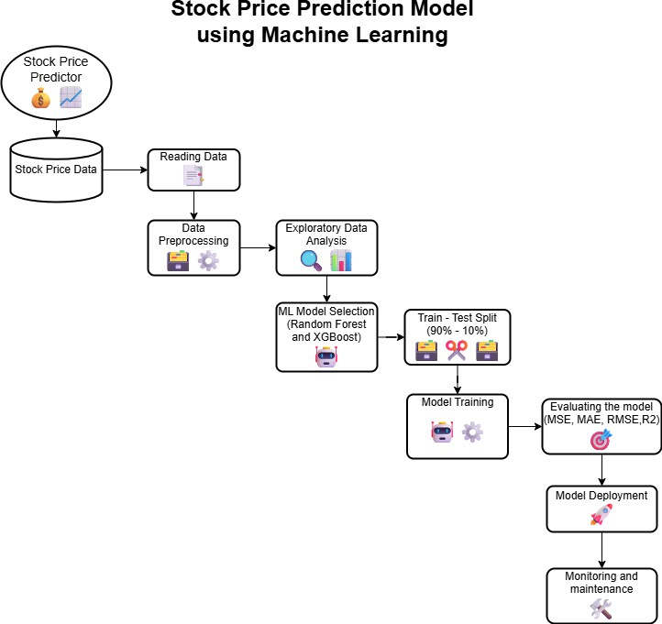

1. **Results**

**Algorithms Used & Evaluation Metrics**

|  |  |  |  |  |
| --- | --- | --- | --- | --- |
| **Algorithm** | **R² Score (%)** | **MSE** | **MAE** | **Accuracy** |
| Linear Regression | 0.726 | 17.43 | 2.84 | 72% |
| Decision Tree Regressor | 0.801 | 15.87 | 2.15 | 80% |
| Random Forest Regressor | 0.949 | 14.64 | 2.46 | 94.9% |
| XGBoost Regressor | 0.951 | 14.0 | 2.55 | 95.1% |

# Evaluation Methods

* + **R² Score (Coefficient of Determination):** Indicates how well the model explains variance in stock prices.
  + **Mean Squared Error (MSE):** Measures average squared difference between predicted and actual values.
  + **Mean Absolute Error (MAE):** Measures average magnitude of errors in predictions.
  + **Root Mean Squared Error (RMSE):** Measures the average magnitude of the errors made by a model